1. Login Screen:-

Password

User Name

Sign Up!

1. If wants to create new account (sign up):-

Sign Up!

1. Standard account (sign up):-

User Name

Password

1. Professional account (sign up):-

User Name

Password

Profession

Phone No

Email Id

1. Standard user after login(choose what they (standard user) looking for):-

What are u looking for?

1. Make up artist
2. Programmer
3. Plumber

1. Show map Standard user after (after they(standard user) choosen what they looking for):-

Professional Name 1 and Distance in Km

Professional Name 2 and Distance in Km

[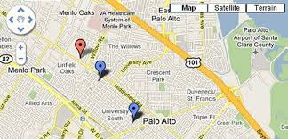](https://www.google.ie/imgres?imgurl=http://codegeekz.com/wp-content/uploads/google-maps-jquery.jpg&imgrefurl=https://codegeekz.com/best-jquery-map-plugins/&docid=at5xBmPNTpI3hM&tbnid=4f0-WSp8goR2XM:&w=825&h=397&bih=631&biw=1366&ved=0ahUKEwiPxN6I--bNAhWiK8AKHYsNC90QMwhTKBswGw&iact=mrc&uact=8)

1. After clicekd on Professional Name 1:-

Name of professional

Email id of professional

Phone no of professional

1. Professional user map screen:-

Display current location of user.